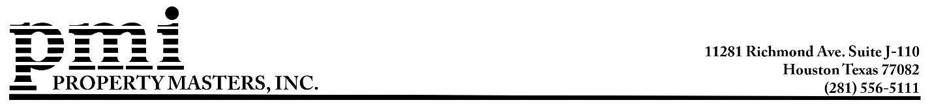
November 24, 2025
Dear Clayton Homeowners:

Enclosed please find your Clayton Homeowners Association account statement, which reflects a 5% increase in the 2026 maintenance assessment. Rising maintenance and operational costs have made this adjustment unavoidable. This change was not made lightly, but it is necessary to ensure ongoing expenses are covered and to continue building reserves for the long-term financial stability of the community.
Reminder: Payments are due on January 1, 2026, and must be received by the bank prior to January 30, 2026, to avoid late fees. Payments received after January 31 will incur a $25 late fee plus 10% per annum interest.
If you choose to submit your payment by mail, note that because correspondence may take several days to be delivered and processed. The bank does not use the postmark date as the date received, only the date the payment is received and processed. To avoid potential USPS delays, please allow plenty of time or consider submitting your payment online. Your payment is considered received once it has been processed and posted to your property’s account.

You have three different ways to pay your maintenance assessment:
- Online Payment Via eCheck or Debit/Credit Card
What do I need to do? Log into your account by going to www.home.propertymastersinc.net/login. Once logged in, click on “Make a Payment”. The following bank processing fees apply: eCheck – $2.95, Debit Card – $5.00, and Credit Card – 3% of the total payment amount
Haven’t set up your account on the Homeowner Portal?
Go to home.propertymasterinc.net/request-account. Fill out the requested information and click “Request”. Your registration key will be emailed within 2 business days. Please do not send multiple requests.

- US Mail/Lockbox
What do I need to do? Write a check or money order payable to Clayton HOA and mail it along with your enclosed payment coupon to the address listed on the coupon. ***Important: Please write your homeowner account number on your payment.
- Your Bank’s Online Bill-Pay
How does it work? If you are already using your bank’s online bill-pay system, please login to the service and verify the processing address. Bill-pay must be set up exactly as below:
Payee: Clayton HOA
Address 1: Property Masters Processing Center
Address 2: P.O. Box 97995
City: Las Vegas State: NV Zip: 89193-7995
Account Number/Reference Number: Your Homeowner Account Number

Upcoming Community Events: The Clayton HOA Annual Meeting is scheduled for 7:00 PM on December 1, 2025, at the clubhouse. If you are unable to attend the meeting, please complete and return the proxy previously mailed to you.
Additionally, you and your family are invited to join your neighbors for Clayton’s Christmas Party on December 13th from 12:00 pm to 3:00 pm at the clubhouse. Enjoy music, sweets, prizes, and family-friendly fun as we celebrate the season!

Please visit the Clayton HOA website, www.claytonhoa.com, for all Clayton HOA information. Email questions and requests to join the mailing list to ClaytonBoard@claytonhoa.com or call 281-556-5111. Board meetings are held on the 4th Thursday of the month at 7:00 p.m. at the clubhouse. All homeowners are welcome to attend these monthly meetings.
Sincerely,
PROPERTY MASTERS, INC.
Stephane Gonzalez, Manager, Ext. 105
Lesha Leighton, Accounting, Ext. 102

Enclosures: 2026 Statement of Account & Envelope

